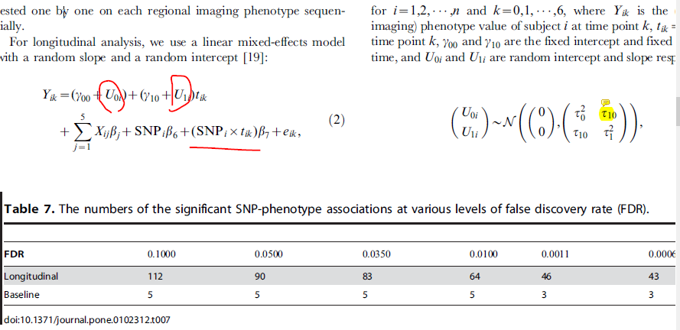

We use the HDL trait as example:

Gamma00 = 74.5

Gamma10 = 0.343

U0i ~ N(0, 26.8638)

U1i ~ N(0, 0.4312)

Cor(U0i, U1i) = -0.89

E_ik ~ N(0, 7.2583&2)

Thus, $\left(\begin{aligned}U0i \\ Ui\end{aligned}\right) \sim N\left(\left(\begin{aligned}0 \\ 0\end{aligned}\right),\left(\begin{matrix}721.666 & -10.30947 \\ -10.30947 & 0.186\end{matrix}\right)\right)$ according to below records.

Sex = -13.85 (0: female; 1:male)

Age_longi = 0.342693 # for 1 year increment. Typically the interval is 3-5 years.

Bmi01 = -0.9513

Beta6 = -0.03 # from real data estimate on signal SNPs’ effect size.

HDL example:

Lme4 result:

> summary(results_reduced[[2]])

Linear mixed model fit by REML t-tests use Satterthwaite approximations to

degrees of freedom [merModLmerTest]

Formula: hdl_longi ~ sex + age_longi + agesq_longi + bmi01 + (1 + age_longi |

id)

Data: phe_cov_longitudinal_longFormat

REML criterion at convergence: 265998

Scaled residuals:

Min 1Q Median 3Q Max

-7.7742 -0.4793 -0.0508 0.4274 8.1475

Random effects:

Groups Name Variance Std.Dev. Corr

id (Intercept) 721.666 26.8638

age_longi 0.186 0.4312 -0.89

Residual 52.684 7.2583

Number of obs: 35422, groups: id, 9705

Fixed effects:

Estimate Std. Error df t value Pr(>|t|)

(Intercept) 7.449e+01 3.780e+00 1.095e+04 19.707 < 2e-16 ***

sex -1.359e+01 2.688e-01 9.642e+03 -50.546 < 2e-16 ***

age_longi 3.427e-01 1.265e-01 1.096e+04 2.708 0.006780 **

agesq_longi -3.715e-03 1.078e-03 1.095e+04 -3.446 0.000571 ***

bmi01 -9.513e-01 2.763e-02 9.590e+03 -34.423 < 2e-16 ***

---

Signif. codes: 0 ‘***’ 0.001 ‘**’ 0.01 ‘*’ 0.05 ‘.’ 0.1 ‘ ’ 1

Correlation of Fixed Effects:

(Intr) sex ag_lng agsq_l

sex -0.009

age_longi -0.976 -0.006

agesq_longi 0.964 0.003 -0.996

bmi01 -0.191 -0.085 -0.004 0.003

Gls result:

Generalized least squares fit by REML

Model: formula

Data: phe_cov_longitudinal_longFormat

AIC BIC logLik

268556.9 268616.3 -134271.5

Correlation Structure: Continuous AR(1)

Formula: ~time | id

Parameter estimate(s):

Phi

0.750201

Coefficients:

Value Std.Error t-value p-value

(Intercept) 77.64299 5.018980 15.46987 0.0000

sex -13.28730 0.251000 -52.93754 0.0000

age_longi 0.24124 0.170463 1.41519 0.1570

agesq_longi -0.00290 0.001451 -2.00087 0.0454

bmi01 -0.95509 0.025888 -36.89256 0.0000

Correlation:

(Intr) sex ag_lng agsq_l

sex -0.004

age_longi -0.987 -0.005

agesq_longi 0.976 0.001 -0.997

bmi01 -0.130 -0.085 -0.007 0.006

Standardized residuals:

Min Q1 Med Q3 Max

-3.7362698 -0.6613336 -0.1181749 0.5316303 8.9330536

Residual standard error: 14.44305

Degrees of freedom: 35422 total; 35417 residual